$$Logistic Regression$$

$$1) Read the data$$

$$2) Preprocess or EDA of the data$$

$$3) Model development$$

$$4) Evaluate the model$$

$$5) Tune the model$$

$$6) Model deployment$$

$$Model development :what is the use case?$$

$$Regression problem: output or target in Numerical format$$

$$Classification problem:output or target in Categorical format$$

$$Cluster or segmentation:we dont have output$$

$$what type of Model you want develop:ML DL NLP$$

$$Loan prediction: Yes or No ML problem \left(DL\right)$$

$$Clasifiy the Dogs vs Cat:DL problem$$

$$Postive or Negative: NLP$$

$$Logistic regression is used for classification problems$$

$$You open one magzine, you want to identify subscription of magzine based on age$$

|  |  |
| --- | --- |
| **Age** | **Subscription** |
| **25** | **Yes** |
| **28** | **No** |
| **35** | **No** |
| **16** | **Yes** |

$$Input: Age Output=Subscription$$

$$We know only Linear regression equation$$

$$subscription=b_{o}+b_{1}*age========\left(1\right)$$

$$what is the problem ,$$

$$when you substitute age=30, subscription=will give some number$$

$$based on a number we can^{'}t conclude we have subscribe the magzine or not$$

$$How can I convert a number will say to me Yes or No$$

$$instead of subscription=$$

$$p\left(subscription\right)>0.5 =yes$$

$$p\left(subscription\right)<0.5 =No$$

$$p\left(subscription\right)=b_{o}+b_{1}*age=========\left(2\right)$$

$$what is the problem in equation-2?$$

how do we define >0.5 =yes?

how to find bo,b1 in this : ols gradient MLE

not sure whether the p(sub) is dependent on b0 and b1 values

can we use ols methods in any model or in that Liner regression model ?

To find the coeff

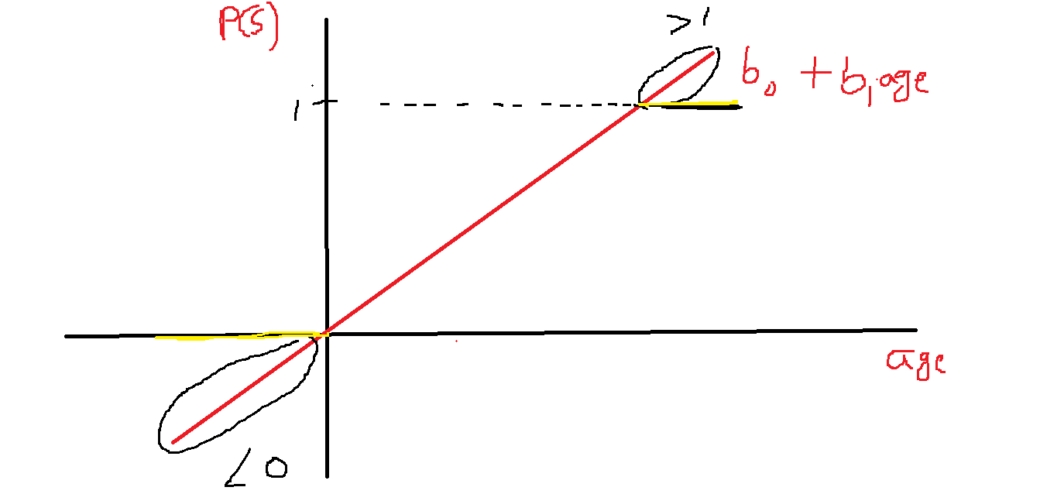



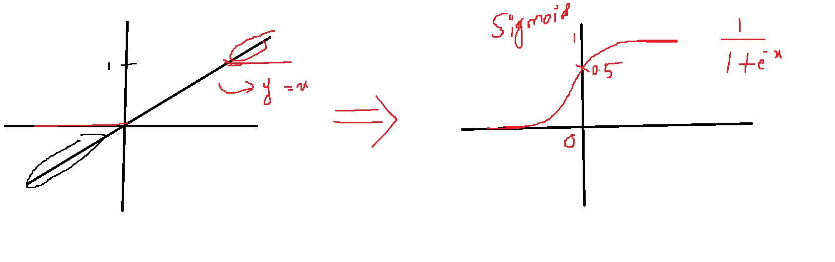

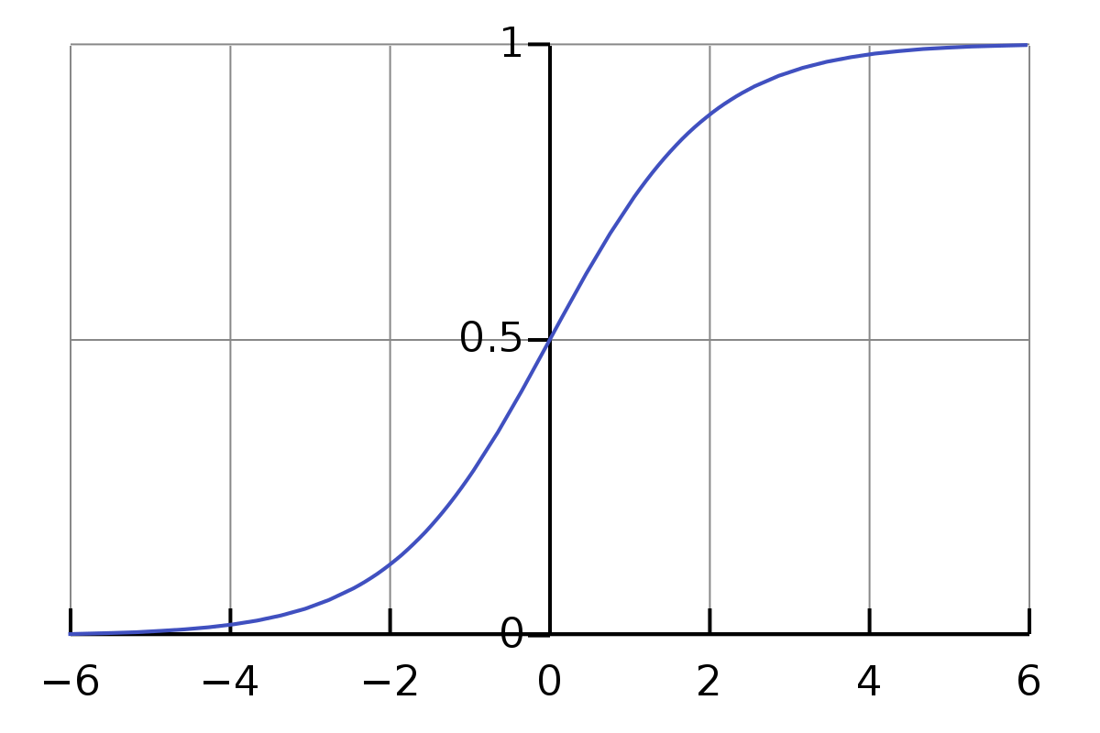

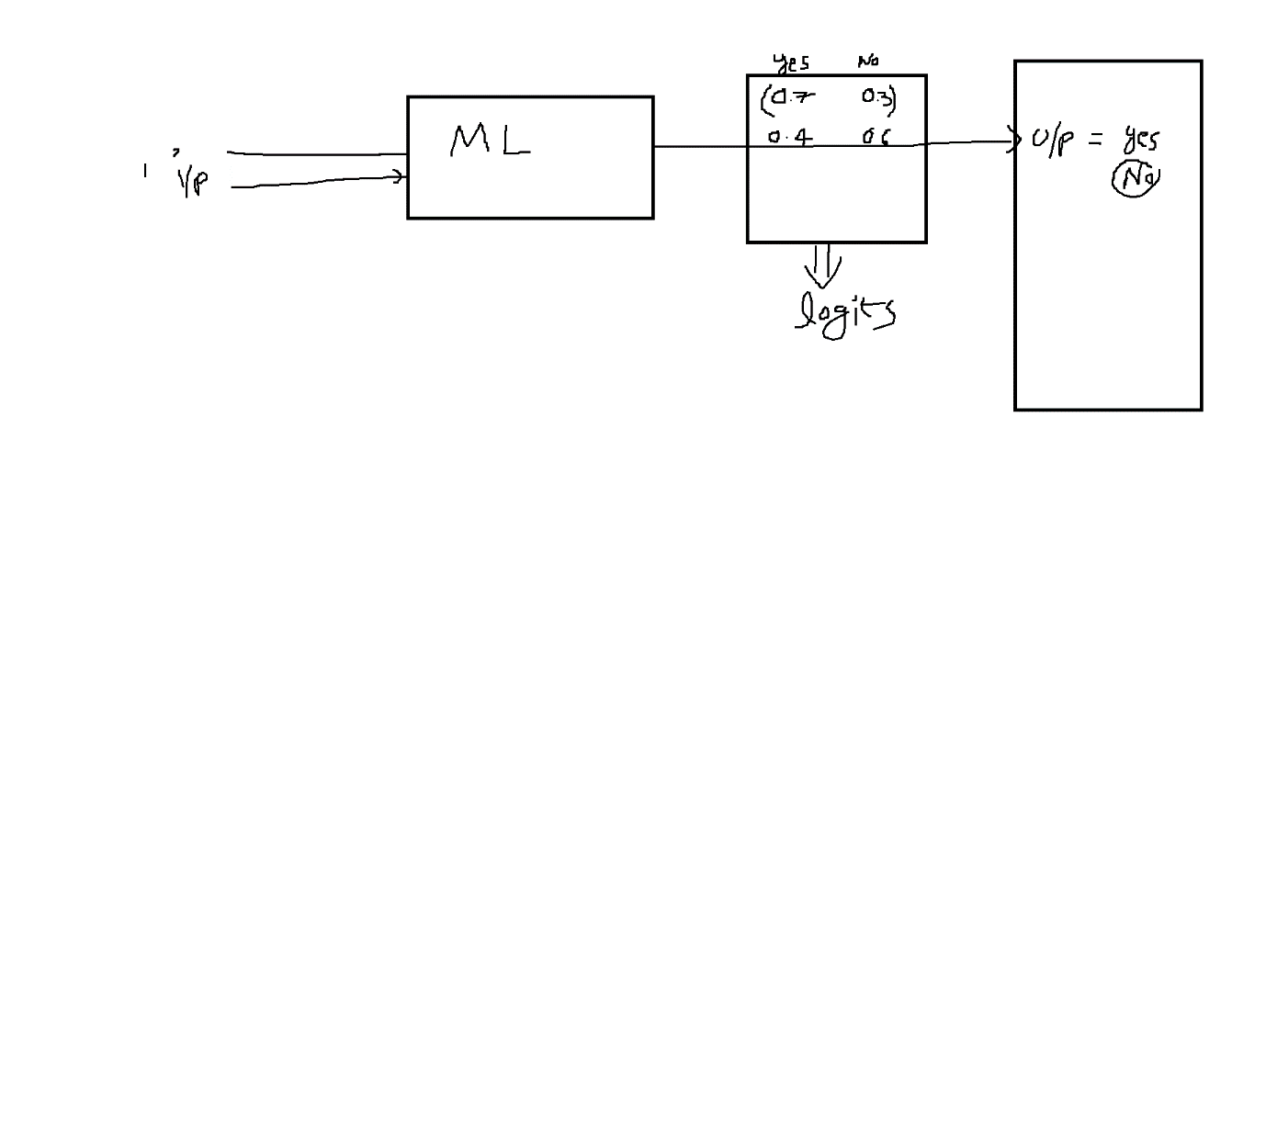

Sir we have only x and y then how we give model for training data as x and p(y)

X1=Age x2=gender x3= income

30 M 50k

X: [30,M,50K] ========= 1/(1+e^-(30*b1+M*b2+50k*b3)